**Make Binary Tree From Linked List:-**

Given a Linked List Representation of Complete Binary Tree. The task is to construct the Binary tree.  
**Note :**The complete binary tree is represented as a linked list in a way where if root node is stored at position i, its left, and right children are stored at position **2*i+1**, **2*i+2** respectively.

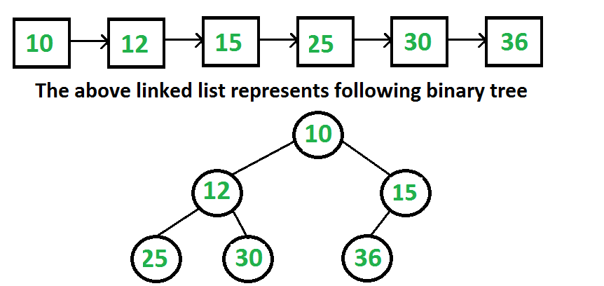  
**Example 1:**

**Input:**

N = 5

K = 1->2->3->4->5

**Output:** 1 2 3 4 5

**Explanation:** The tree would look like

    1

  /  \

  2    3

/  \

4   5

Now, the level order traversal of

the above tree is 1 2 3 4 5.

**Example 2:**

**Input:**

N = 5

K = 5->4->3->2->1

**Output:** 5 4 3 2 1

**Explanation:** The tree would look like

    5

   /  \

 4    3

/ \

2    1

Now, the level order traversal of

the above tree is 5 4 3 2 1.

**Your Task:**  
The task is to complete the function **convert**() which takes head of linked list and **root**of the tree as the reference. The driver code prints the level order.

**Constraints:**  
1 <= N <= 103  
1 <= Ki <= 103